 

**ADVANCED PROGRAMMING / CODING (MACHINE LEARNING/DATA MINING)**

**Report**

**Grape And Strawberry Plant Disease Detection**

**by**

**Group Members**

1. **Abdul Sami Wadho**
2. **Taimoor khan**

**Submit To : Sir Sajid Majeed**

**Signature.**

**Report Outline:**

1. **Introduction**
2. **Literature Review/Background**
3. **Research Methodology**
4. **Results and Discussion**
5. **Conclusion and Future Directions**

**. Introduction**

**Title:** Detection of Grape and Strawberry Plant Diseases Using Convolutional Neural Networks

**Introduction:** Plant diseases pose a significant threat to agriculture, reducing crop yields and affecting food security. Early and accurate detection of plant diseases is crucial for effective management and control. This project focuses on developing a Convolutional Neural Network (CNN) model to detect diseases in grape and strawberry plants using image processing techniques. The model is trained to classify images of grape and strawberry leaves into various disease categories and healthy leaves.

**2. Literature Review/Background**

**Background:** The detection of plant diseases using image processing and machine learning techniques has gained significant attention in recent years. Traditional methods of plant disease detection involve manual inspection, which is time-consuming and often inaccurate. Machine learning, particularly CNNs, offers a promising solution for automated and accurate disease detection.

**Literature Review:**

* **Existing Methods:** Previous studies have explored various machine learning algorithms, including Support Vector Machines (SVM), k-Nearest Neighbors (k-NN), and deep learning models for plant disease detection.
* **CNN in Disease Detection:** CNNs have shown superior performance in image classification tasks due to their ability to automatically extract relevant features from images.
* **Dataset Utilization:** Several public datasets of plant disease images have been utilized in research, such as the PlantVillage dataset.

### 3. Research Methodology

**Dataset:** The dataset consists of images of grape and strawberry leaves categorized into different disease classes and healthy leaves. The images are preprocessed and augmented to enhance the model's performance.

**Model Architecture:** A CNN model is developed using TensorFlow and Keras. The model architecture includes several convolutional layers, pooling layers, and dense layers. Early stopping is implemented to prevent overfitting.

**Steps:**

1. **Data Loading and Preprocessing:**

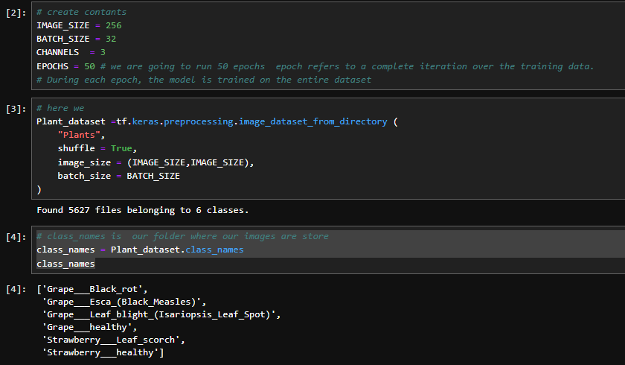

1. **Data Augmentation:**

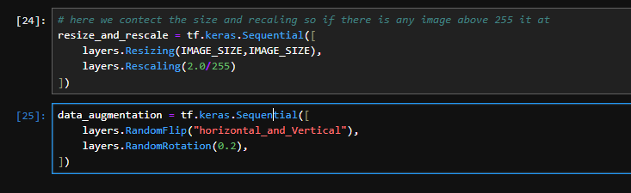

1. **Model Building:**

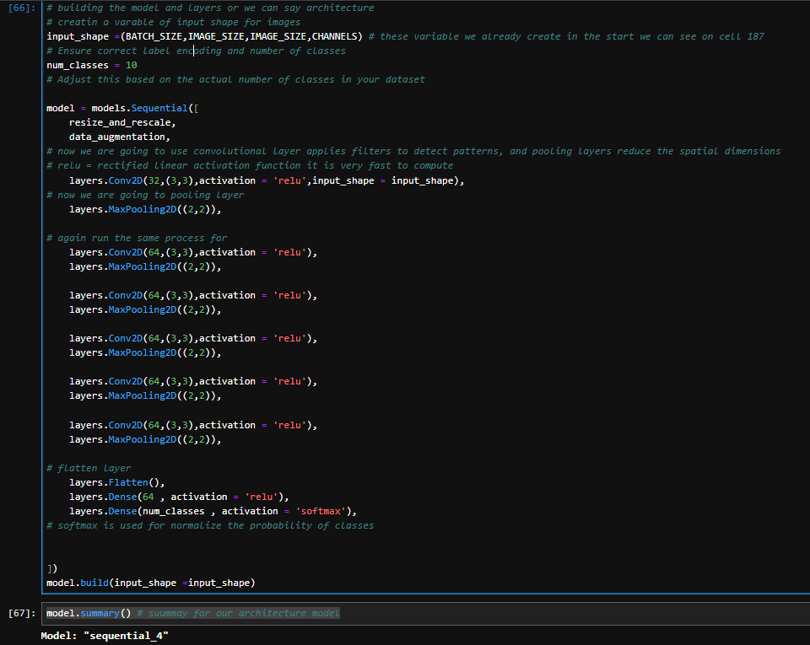

1. **Training the Model:**

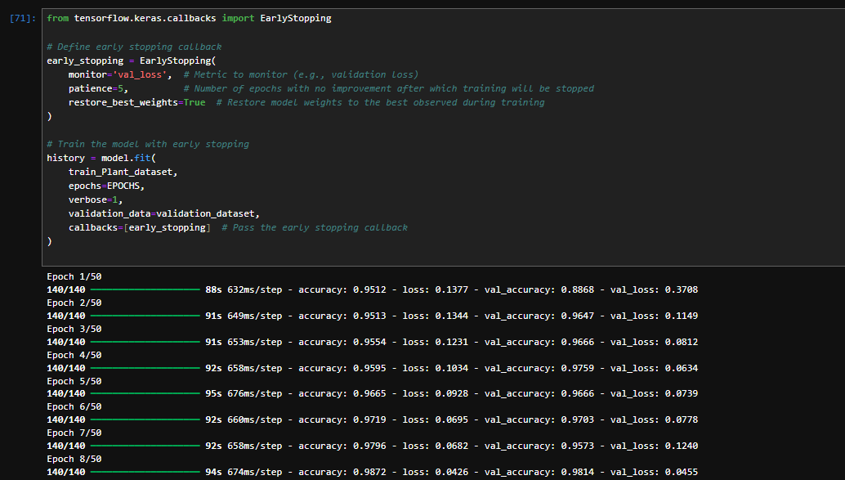

**4. Results and Discussion**

**1. Model Evaluation:** The model's performance is evaluated using accuracy and loss metrics on the test dataset. Visualizations of training and validation accuracy and loss are provided to assess the model's learning process.

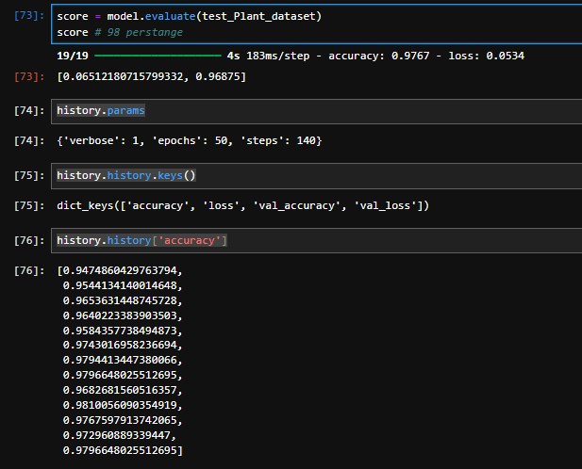

**2. Visualization of Results:** Plots showing the training and validation accuracy and loss over the epochs are presented.

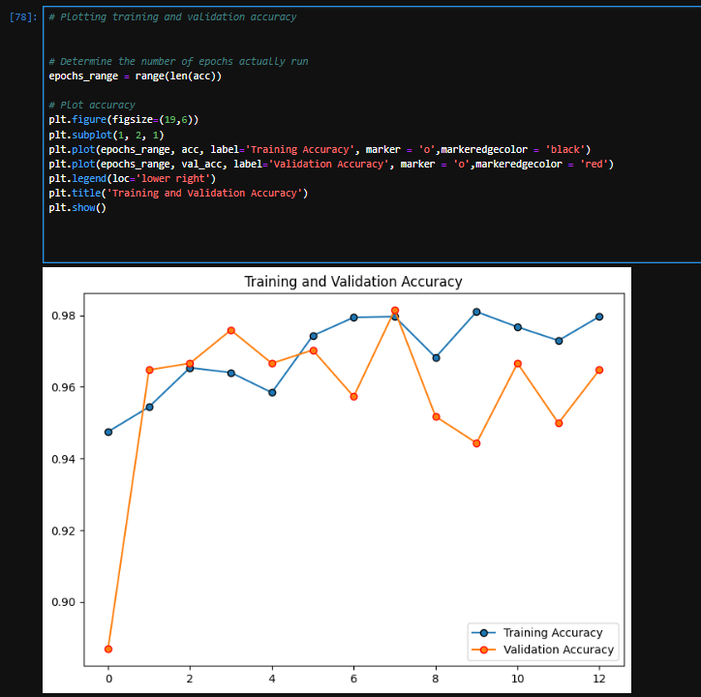

**5. Conclusion and Future Directions**

**Conclusion:** The developed CNN model effectively detects diseases in grape and strawberry plants with high accuracy. The results demonstrate the potential of deep learning models in agricultural applications for disease detection.

**Future Directions:** Future work could involve:

* Expanding the dataset to include more plant species and disease categories.
* Improving the model by experimenting with different architectures and hyperparameters.
* Implementing real-time disease detection using mobile applications.